Author: Tina Cocuzza, MD and Tiffany Murano, MD Reviewer: Lisa Jacobson, MD

Case Title: Incarcerated Hernia

Target Audience: medical students, nurses, paramedics, residents, other

Primary Learning Objectives:
1. Recognition of incarcerated hernia
2. Recognition of possible bowel ischemia
3. Demonstration of appropriate treatment plan for incarcerated hernia and bowel ischemia

Secondary Learning Objectives:
1. Explain the diagnosis and procedures to the patient
2. Employ effective communication with the consultant
3. Appropriate utilization of resources

Critical actions checklist
- Provide antipyretics and appropriate analgesia
- Diagnose hernia on physical exam and attempt reduction
- Attempt reduction of hernia with Trendelenberg, further pain control, and/or anxiolytics/sedation
- Call an emergent general surgery consult for incarcerated hernia and discuss possibility of bowel ischemia/strangulation

For Examiner Only

Author: Tina Cocuzza, MD and Tiffany Murano, MD Reviewer: Lisa Jacobson, MD

Case Title: Incarcerated Hernia

CASE SUMMARY

CORE CONTENT AREA

Gastrointestinal

SYNOPSIS OF HISTORY/ Scenario Background
The patient is a 32 year old male with no significant past medical history who presents with right lower quadrant pain and subjective fever at home x 2 days. The patient’s surgical history (which turns out to be of no significance) is of an exploratory laparotomy due to a stab wound four years ago. The patient does not mention and does not volunteer the information that he has scrotal pain and swelling unless specifically asked by the examinee. If asked, the patient admits he has scrotal pain and swelling. There is no penile discharge or dysuria. If not specifically asked the patient will only complain of right lower quadrant pain. There is no nausea, vomiting, or diarrhea. His bowel habits have been normal.

SYNOPSIS OF PHYSICAL
On triage vitals the patient is tachycardic and febrile orally. He has diffuse abdominal tenderness that is worse in the RLQ, with voluntary guarding in the RLQ. The patient has a firm, tender, right inguinal hernia on GU exam, but this is ONLY discovered if the examinee fully undresses the patient and asks specifically about genital/GU exam. The examinee may try to reduce the hernia and will be unsuccessful. The examinee should make serious attempts to reduce hernia, including Trendelenberg position, administration of pain medications, and possible anxiolytics/sedatives. The hernia will not be reducible. The examinee should consult the on-call general surgeon and communicate that the hernia is incarcerated and the concern for possible strangulation given the patient’s fever, leukocytosis, and elevated lactate. The examinee should not obtain a CT scan prior to calling general surgery. If a CT scan is obtained it will reveal bowel ischemia. The examinee should be marked down if a CT scan is obtained prior to surgical consultation.

For Examiner Only

CRITICAL ACTIONS
Scenario branch points/ PLAY OF CASE GUIDELINES

- Critical Action

Provide antipyretics and appropriate analgesia

Cueing Guideline:
- The nurse may say, “Doctor, the patient still looks very uncomfortable.”
- The patient may say, “Doctor, my stomach still really hurts.”

- Critical Action

Diagnose hernia on physical exam and attempt reduction

Cueing Guideline:
- The general surgery consult may ask the examinee what he thinks is wrong with the patient.
- The nurse may ask if she can place a foley and when she does she may say, “Doctor, I noticed a swelling in the patient’s scrotum.”
- If the hernia is recognized but no attempt made, the general surgery consultant may ask the examinee if he was able to reduce the hernia.

- Critical Action

Attempt reduction of hernia with Trendelenberg, further pain control, and/or anxiolytics/sedation

Cueing Guideline:
- The general surgery consultant may ask the examinee what he/she did to attempt to reduce the hernia.
- The nurse may ask if there’s anything else the examinee would like to try.

- Critical Action

Call an emergent general surgery consult for incarcerated hernia and discuss possibility of bowel ischemia/strangulation

Cueing Guideline:
- The patient may ask if he is going to be admitted.
- If examinee attempted reduction the nurse may ask if there’s anyone else the doctor is going to call for help.

SCORING GUIDELINES
(Critical Action No.)
1. Provide antipyretics and appropriate analgesia
2. Diagnose hernia on physical exam and attempt reduction
3. Attempt reduction of hernia with trendelenberg, further pain control, and/or
anxiolytics/sedation
4. Call an emergent general surgery consult for incarcerated hernia and discuss possibility of bowel ischemia/strangulation

For Examiner Only

HISTORY

Onset of Symptoms: Yesterday

Background Info: 32 year-old male presents with right lower quadrant pain and fever since yesterday. The pain began suddenly and was so severe patient was unable to sleep last night so came to ED first thing this morning.

Chief Complaint: “My stomach won’t stop hurting.”

Past Medical Hx: None

Past Surgical Hx: Exploratory laparotomy secondary to stab wound 4 years ago

Habits: Smoking: 1 PPD
ETOH: Socially
Drugs: Marijuana occasionally

Family Medical Hx: Non-contributory

Social Hx: Marital Status: single
Children: None
Education: High School
Employment: Employed as a salesman at local appliance store

ROS: General: (+) fever/chills
GI: No nausea, no vomiting. No diarrhea. Last bowel movement was the day prior. He has had no flatus today.
GU: no dysuria, no penile discharge; (+) scrotal swelling and tenderness

For Examiner Only

PHYSICAL EXAM

Patient Name: Kenny Jones Age & Sex: 32 year-old male

General Appearance: Well-developed, well-nourished male in moderate distress

Vital Signs: T: 99.4°F (oral), 100.4 °F (rectal), BP: 135/85 HR: 110 RR: 18
O₂ Sat: 99% on room air

Head: Normal

Eyes: Normal

Ears: Normal

Mouth: Normal

Neck: Normal

Skin: Normal

Chest: Normal

Lungs: Normal

Heart: Tachycardic, RRR, no murmur, rub, or gallop

Back: No CVA tenderness

Abdomen: Soft with diffuse tenderness, worse in RLQ. (+) voluntary guarding. No rebound or peritoneal signs

GU: (only evident if examinee completely undressed patient and asks to do GU exam): Right inguinal hernia, firm and tender, not reducible.

Extremities: Normal

Rectal: Non-tender, heme negative

Pelvic: N/A

Neurological: Normal

Mental Status: Normal

For Examiner Only

STIMULUS INVENTORY

#1 Emergency Admitting Form

#2 CBC

#3 BMP

#4 U/A

#5 ABG

#6 Lactate

#7 Toxicology

#8 CXR

#9 KUB

#10 CT abdomen/pelvis

#11 Photograph of patient’s presentation

#12 Debriefing materials

For Examiner Only

LAB DATA & IMAGING RESULTS

Stimulus #2 Stimulus #5
Complete Blood Count (CBC) Arterial Blood Gas
WBC 15.0/mm³ pH 7.30
Hgb 13.7 g/dL pCO₂ 32 mm Hg
Hct 41.0 % pO₂ 95 mm Hg
Platelets 271/mm³ O₂ Sat 99 %
Differential
Segs 80% Stimulus #6
Bands 10% Lactate 3.5
Lymphs 8%
Monos 2%
Eos 0%

Stimulus #7
Toxicology ETOH 0
Stimulus #3 Urine
Basic Metabolic Profile (BMP) Cocaine Neg
PCP Neg
Na⁺ 141 mEq/L Cannabinoids Neg
K⁺ 4.0 mEq/L Benzodiazepines Neg
CO₂ 17 mEq/L Amphetamines Neg
Cl⁻ 110 mEq/L Opiates Neg
Glucose 107 mg/dL Barbiturates Neg
BUN 10 mg/dL
Creatinine 1.0 mg/dL

Stimulus #4 Diagnostic Imaging
Urinalysis (U/A)
Color yellow Stimulus #8
Specific Gravity 1.010 CXR: Normal
Glucose neg
Protein neg Stimulus #9
Ketone neg KUB: Normal
Leuk. Est. neg
Nitrite neg Stimulus #10
WBC 0-1 CT abdomen/pelvis with contrast:
RBC 0-1 Right inguinal hernia with evidence of
Ischemia

Stimulus #11
Photograph of patient’s presentation

Learner Stimulus #1

ABEM General Hospital

Emergency Admitting Form

Name: Kenny Jones
Age: 32 years
Sex: Male
Method of Transportation: Private car
Person giving information: Patient
Presenting complaint: Abdominal Pain

Background: Patient ambulated into the ED c/o right lower quadrant pain and fever since yesterday. The pain began suddenly and was so severe patient was unable to sleep last night so came to ED first thing this morning.

Triage or Initial Vital Signs
BP: 130/89
P: 110
R: 18
T : 100.4 °F (rectal)

Learner Stimulus #2

Complete Blood Count (CBC)
WBC 15 /mm³
Hgb 13.7g/dL
Hct 41%
Platelets 271/mm³
Differential
Segs 80%
Bands 10%
Lymphs 8%
Monos 2%
Eos 0%

Learner Stimulus #3

Basic Metabolic Profile (BMP)
Na⁺ 141 mEq/L
K⁺ 4.0 mEq/L
CO₂ 17 mEq/L
Cl⁻ 110 mEq/L
Glucose 107 mg/dL
BUN 10 mg/dL
Creatinine 1.0 mg/dL

Learner Stimulus #4

Urinalysis (U/A)
Color yellow
Sp gravity 1.010
Glucose neg
Protein neg
Ketone neg
Nitrite neg
WBC 0-1
RBC 0-1

Learner Stimulus #5

Arterial Blood Gas
pH 7.30
pCO₂ 32 mm Hg
pO₂ 95 mm Hg
O₂ Sat 99 %

Learner Stimulus #6

Lactate 3.5

Learner Stimulus #7

Toxicology
ETOH 0

Urine
Cocaine Neg
PCP Neg
Cannabinoids Neg
Benzodiazepines Neg
Amphetamines Neg
Opiates Neg
Barbiturates Neg

Learner Stimulus #8

CXR: Normal

Learner Stimulus #9

KUB: Normal

Learner Stimulus #10

CT abdomen/pelvis with contrast: Right inguinal hernia with evidence of ischemia

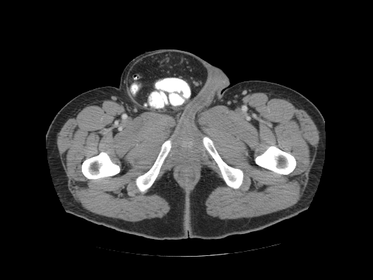

Learner Stimulus #11

Photograph of patient’s presentation

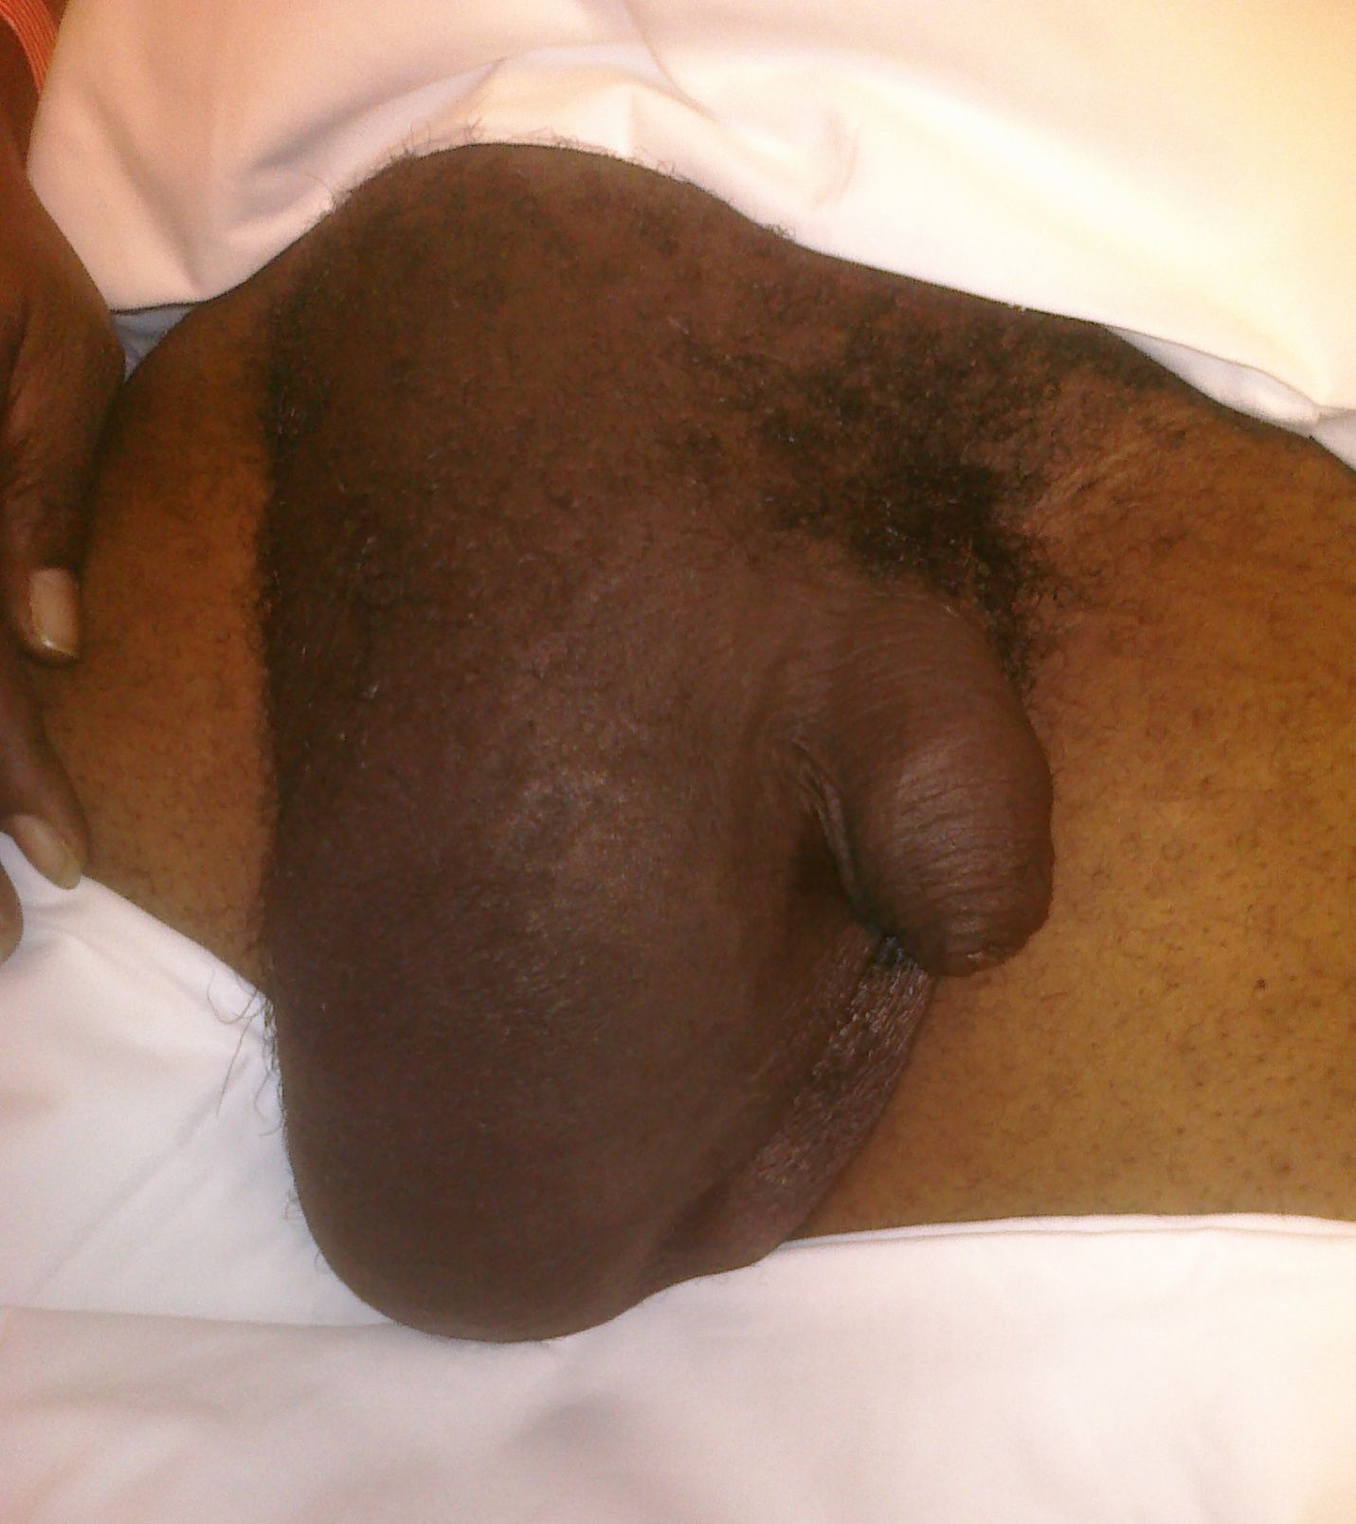
For Examiner

Date: Examiner: Examinee(s):
Scoring: In accordance with the Standardized Direct Observational Tool (SDOT)

The learner should be scored (based on level of training) for each item above with one of the following:
NI = Needs Improvement
ME = Meets Expectations
AE = Above Expectations
NA= Not Assessed

Critical Actions | NI | ME | AE | NA | Category
Obtain a focused history pertinent to the chief complaint of abdominal pain |  |  |  |  | P, PC, MK, PBL
Performs comprehensive abdominal and genitor-urinary examination |  |  |  |  | PC, MK, PBL
Diagnose hernia and attempt reduction |  |  |  |  | PC, MK, PBL
Consults general surgery emergently |  |  |  |  | PC, MK, PBL, SBP
Recognize possible bowel ischemia |  |  |  |  | PC, MK, PBL
Administers analgesia and antipyretics |  |  |  |  | P, PC, MK, PBL
Demonstrate effective communication with patient and general surgery consultant |  |  |  |  | P, PC, MK, ICS,

The score sheet may be used for a variety of learners. For example, in using the case for 4th year medical students, the key teaching points of the case may be the recognition of shock and treatment with appropriate fluid resuscitation. Other items may be marked N/A= not assessed.

Category: One or more of the ACGME Core Competencies as defined in the SDOT

PC= Patient Care
Compassionate, appropriate, and effective for the treatment of health problems and the promotion of health
MK= Medical Knowledge
Residents are expected to formulate an appropriate differential diagnosis with special attention to life-threatening conditions, demonstrate the ability to utilize available medical resources effectively, and apply this knowledge to clinical decision making
PBL= Practice Based Learning & Improvement
Involves investigation and evaluation of their own patient care, appraisal and assimilation of scientific evidence, and improvements in patient care
ICS= Interpersonal Communication Skills
Results in effective information exchange and teaming with patients, their families, and other health professionals
P= Professionalism
Manifested through a commitment to carrying out professional responsibilities, adherence to ethical principles, and sensitivity to a diverse patient population
SBP= Systems Based Practice
Manifested by actions that demonstrate an awareness of and responsiveness to the larger context and system of health care and the ability to effectively call on system resources to provide care that is of optimal value

Keywords for future searching functions
Hernia, Incarceration, inguinal, acute abdominal pain

References
- Matthews RD, Neumayer L: Inguinal hernia in the 21st century: an evidence based review. Curr Probl Surg 45: 261, 2008.
- Ruhl CE, Everhart JE: Risk factors for inguinal hernia among adults in the US population. Am J Epidemiol 165: 1154-1161, 2007.
- Rutkow IM: Demographic and socioeconomic aspects of hernia repair in the United States in 2003. Sug Clin North Am 83: 1045-1051, 2003
- Byars, D in Tintinalli J, Stapczynski S et al Tintinalli’s Emergency Medicine: A Comprehensive Guide, 7th e. The McGraw Hill Company, Inc, 2004
- Jamadar DA, Franz GM: Inguinal region hernias. Ultrasound Clin 2: 714, 2007.
- Robinson P, Hensor E, Lansdown MJ, et al: Inguinofemoral hernia: accuracy of sonography in patients with indeterminate clinical features. Am J Roentgenol 187: 1168-1178, 2006.
- Zarvan NP, Lee FT Jr, Yandow DR, Unger JS: Abdominal hernias: CT finders Am J Roentgenol 164: 1391, 1995
- Deutsch AA, Eviatar E, Gutman H, Reiss R: Small bowel obstruction: a review of 264 cases and suggestions for management. Postgrad Med J 65: 463, 1989

Has this work been previously published? No

Debriefing Materials:

A hernia is the protrusion of part of an organ through a weak point in the wall of the body cavity that normally contains it.¹ They are classified by anatomic location, the contents contained within the hernia, and whether the hernia is reducible, incarcerated, or strangulated.¹ Abdominal wall hernias are one of the most common surgical complaints and inguinal hernias are the most common type of hernia. About 500,000 inguinal hernia are identified annually in the US and general surgeons performed almost 800,000 inguinal hernia repair in the United States in 2003.^{2,3}

A hernia is called reducible when the hernia sac itself is soft and easily reduced through the hernia defect. A hernia is incarcerated when it is firm, often painful, and non-reducible by direct manual pressure. Strangulation develops as a consequence of incarceration and is due to reduced blood flow to the organ. It will present as severe pain at the hernia site, possibly with signs and symptoms of intestinal obstruction, toxic appearance, and skin changes overlying the hernia sac. A strangulated hernia is an acute surgical emergency.⁴

Diagnosis is primarily clinical, however, more recently, imaging studies have been shown to have a role as both a primary diagnostic tool as well as a way to identify complications.⁵ Plain films may be helpful in patients with perforation or obstruction but are usually indeterminate or non-diagnostic.⁴ In patients where the diagnosis is equivocal ultrasound is an accurate diagnostic modality.⁶ Bedside ED US using a linear high frequency probe with color or power Doppler of the hernia sac can be useful in these borderline cases to establish the presence or absence of blood flow.⁵ CT scan is the best radiographic test for diagnosis and can identify uncommon hernia types as well as demonstrate incarceration and strangulation.⁷

If the hernia is easily reduced, the patient can be referred for elective outpatient surgery.⁴ If the hernia is incarcerated but not strangulated an attempt to manually reduce the hernia should be made. If unsuccessful after one or two attempts, general surgery should be consulted. ⁴ If there is any concern for strangulation, general surgery consultation should be made immediately.⁸

