CORD Sports Medicine Toolkit: Limp in a Child
Nicole Prendergast MD1

Background
Limping or inability to bear weight in a child is a common chief complaint that brings parents into the emergency department. In most children limping is the result of a mild, self-limiting injury, however it can also be a sign of more serious illness. Understanding the differential diagnosis, historical features, and clinical presentations of patients experiencing different causes is important for identifying life threats and initiating appropriate workup and treatment.

Normal Gait
Three phases in gait:
- Contact: heel strike to flat foot
- Stance: flat foot to lifting heal from ground (most weight bearing)
- Propulsion: weight transfers to the toes and push off

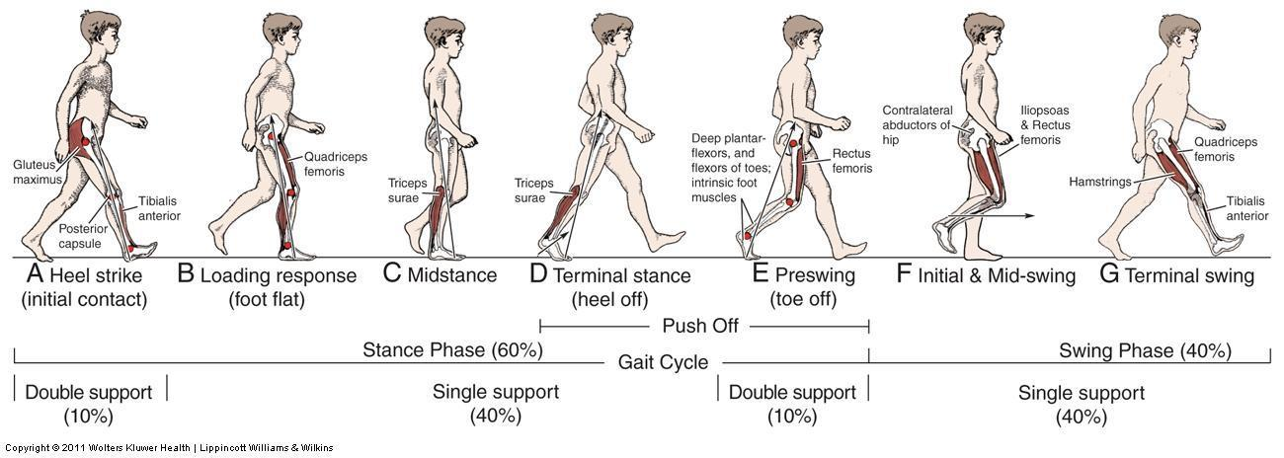

Development: the age of the child must be considered for characterization of normal gait.
- Toddler: wide base of support, short asymmetric steps, occasional foot slapping with increased speed, lack of corresponding arm coordination
- Children (age 3-5): more fluid, symmetric, improved overall coordination, at age 7 equivalent to adults

Abnormal gait: Limping is the deviation from normal pattern of gait.

Antalgic Gait – “hobbling gait”, normal contact phase with abbreviated stance to avoid weight bearing on injured side
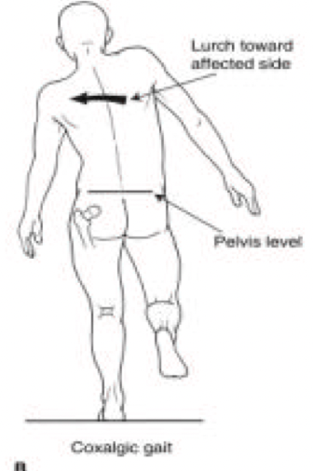
Trendelenburg Gait – unaffected side dips to the floor, affected side’s hip abductor muscles are unable to stabilize the pelvis (neuropathic or biomechanical problem)
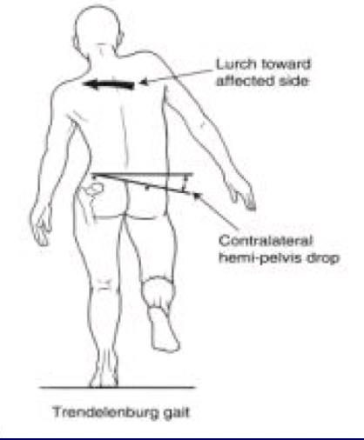
Circumduction Gait – swings foot laterally, foot or ankle injury or limb-length discrepancy
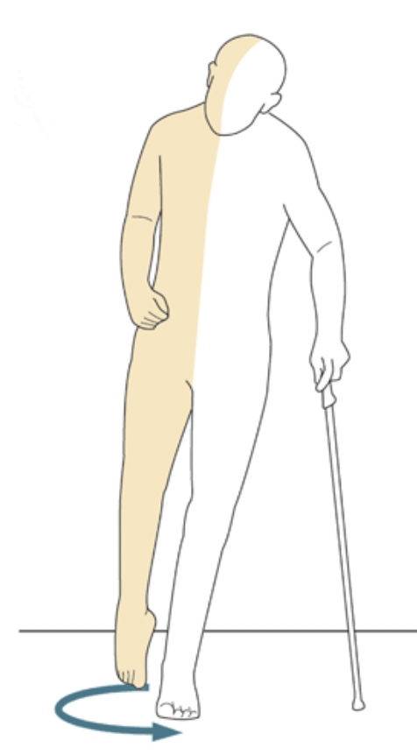
Stiff-Legged Gait – walks with knees locked, attempt to avoid use of gastrocnemius muscle
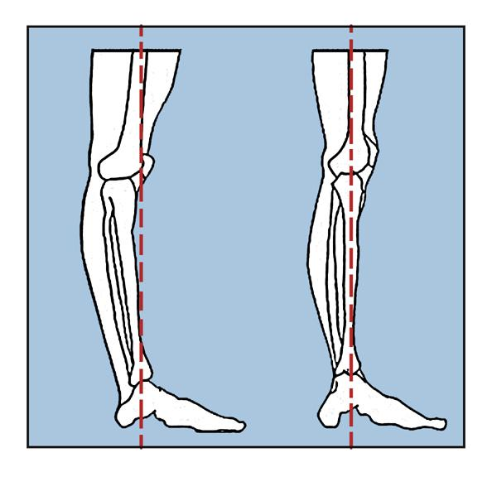

Equinus Gait – toe walking
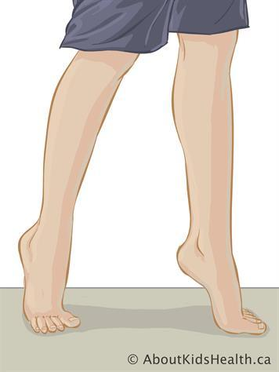

History in Child with a Limp
- Family and medical history: cerebral palsy, spinal cord tumors, neuromuscular findings, metabolic disturbances
- Antecedent trauma, fever, exposures, respiratory findings, weight loss, systemic symptoms
- Progression of signs and symptoms:
  - Can the child bear weight? If so, what does the gait look like?
  - Duration and progression of limp
  - Is there pain?

Physical Exam in Child with a Limp
- Observation during ambulation
- Abdominal exam: examine for tenderness, hepatosplenomegaly
- Examination of back, palpate for tenderness
- Extremity: strength, sensation, reflexes, tenderness (anterior and inferior iliac spines)
  - Look for deformity, erythema, swelling, ecchymoses, abrasion, effusion
  - Consider referred pain
  - Examine for difficulty with abduction (ie. Limited in hip dysplasia)
- 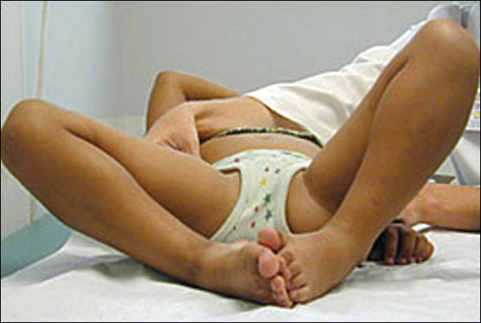

  - Galeazzi sign: child lying supine with hips and knees flexed, knee on affected side lower than the knee on normal side (length discrepancy)
  - Faber test: supine, flex abduct and externally rotate hip (pain indicates SI joint pathology)
  - Look for symmetry of internal rotation, lateralizing pain, guarding
- 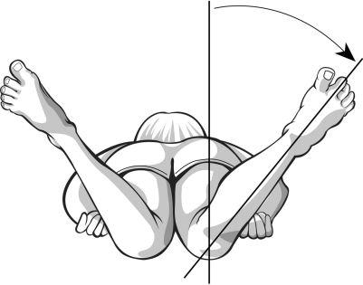 Keep the pelvis on the bed and rotate the lower extremity laterally → internal hip rotation
  - Ie. AVN will not allow full internal rotation due to impingement of necrotic femoral head, SCFE
- Skin: examination for any rash or abnormal skin lesions

Differential diagnosis for extremity pain
- Trauma:
  - Fracture (Toddler’s fracture)
  - Sprain, contusion
  - Foreign body, splinter
  - Herniated disc
  - Hemarthrosis (bleeding disorder)
- Overuse
  - Osgood Schlatter disease
  - Sever disease
- Infection:
  - Osteomyelitis
  - Iliopsoas abscess
  - Septic arthritis
  - Discitis
  - Viral
  - Lyme disease
- Inflammation
  - Toxic synovitis
  - Juvenile Idiopathic Arthritis
  - Ankylosing spondylitis
- Vascular
  - Legg-Calve-Perthes disease
- Degenerative
  - Slipped capital femoral epiphysis
  - Neuromuscular disease
- Metabolic
  - Rickets
  - Hyperparathyroid
- Neoplasm
  - Osteochondroma
  - Osteoid Osteoma
- Gastrointestinal:
  - Appendicitis
  - Testicular/Ovarian Torsion

Pneumonic PEM Playbook STOP LIMPING

Septic arthritis
Toddler fracture
Osteomyelitis
Perthes disease (idiopathic AVN)

Limb length discrepancy
Inflammatory (transient synovitis)
Malignancy
Pyomyositis
Iliopsoas abscess
Neurologic
Gastrointestinal (appendicitis), genitourinary (testicular/ovarian)

Diagnostic Testing
- Laboratory tests: CBC, ESR, CRP, blood cultures
- Imaging
  - X-Ray
  - Ultrasound (foreign body, effusion)
  - CT (occult fractures, benign lesions)
  - MRI (MSK infections, neoplasms, vascular abnormalities

Overuse injury:
- Rapid increase in intensity and frequency of training regimen, introduction of unfamiliar training
- Inflammation typically at apophysis – secondary growth center at tendon insertion
  - Osgood-Schlatter: apophysitis of tibial tubercle
    - Risk factors: 9-14 yo, M>F, running or jumping sports
    - Hx: Limp, pain worse with activity, tenderness or swelling on tibial tubercle
    - Physical exam: tenderness over apophysis, soft tissue swelling +/- mass
    - Rx: ice, NSAIDs, activity restriction, physical therapy, resolves with fusing of tibial tubercle apophysis age 14-15
  - Sever disease: apophysitis of calcaneal apophysis at or distal to Achilles tendon insertion
    - Risk factors: 7-9 yo, M>F, sports with hardwood floor, cleats
    - Hx: Heel pain, limp with toe walking, worsens with activity
    - Physical exam: tenderness heel, limited ankle dorsiflexion
    - Rx: ice, NSAIDs, limit workouts on hard surfaces and in cleats

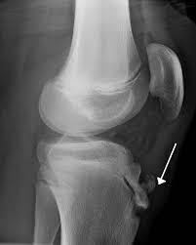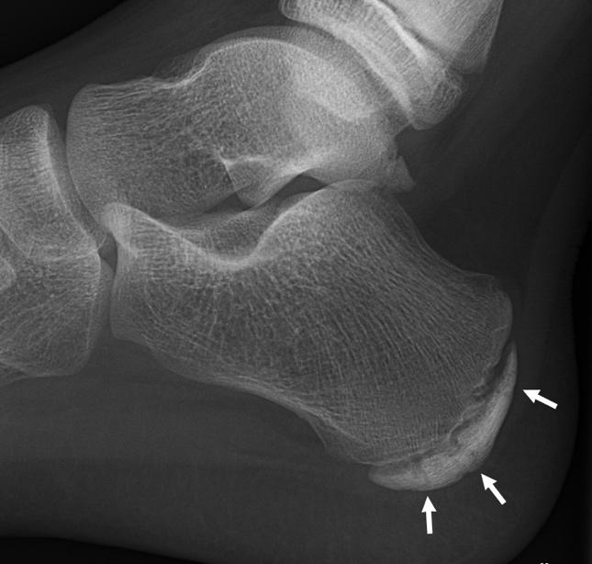

Traumatic injuries: (most common cause of limp) include sprains, muscle strains, contusion, fracture
- Fractures (most common cause of limp) include sprains, muscle strains, contusion, fracture
  - Stress fracture: microtrauma 2/2 to repetitive loading
  - Toddler’s fracture: spiral or oblique fractures that involve both cortices
    - Limp after minor injury or fall
    - Initial radiographs negative, appear 10 days to 2 weeks after
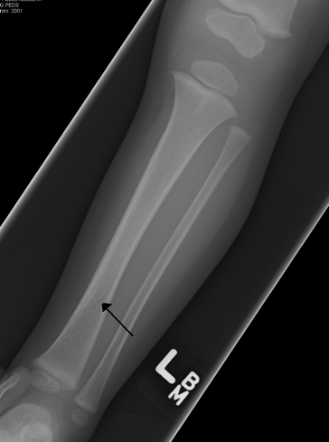
    - Toddler with limp after minor trauma cast after 4 weeks (below-knee walking cast)

  - Foot fracture: nondisplaced fractures of metatarsals and phalanges 2/2 twisting or stubbing
    - Hard-soled shoe
    - Seymour fracture: fracture of the big toe at distal phalanx at the physis
      - Bleeding at proximal edge of nail or nail disruption
      - Fracture partially can reduce, be hidden by the nail fold
      - Open fracture
      - Needs nail removal, irrigation, debridement, reduction, abx
- Puncture wounds/Foreign bodies
  - Suspect in plantar cellulitis, draining laceration, induration
  - Need XR
  - Antibiotics
  - Surgical exploration if large, wood
- Compartment syndrome: swelling and bleeding into muscle compartments
  - Signs; Children 3 As (vs Adults 6 Ps) Anxiety, Agitation, Analgesia
  - Most common in after trauma (fractures of tibial shaft), surgery
- Vascular injury
- ***consider nonaccidental trauma if inconsistent story, injury not correlating with developmental level, metaphyseal corner fractures, epiphyseal separations, multiple fractures at different stages of healing

Infection or Inflammatory Conditions:
- Septic Arthritis
  - Hx: painful limp, fever
  - Physical Exam:
    - Knee or ankle: limited joint rom, swelling, erythema, tenderness
    - Hip: flexion slight abduction, external rotation, resists passive hip movement
  - Septic hip: hip cartilage and blood supply begins within 6-12 hours
  - X-Ray normal, US effusion, mild elevation of WBC, ESR, CRP
  - Synovial fluid: synovial fluid WBC >50,000, >75% PMNs, + gram stain
  - Rx: Antibiotics, open drainage of join
- Toxic (Transient) synovitis
  - 85% of children with atraumatic hip pain and limping
  - Risk factors: 3-8 yo, viral infection 2 weeks – 1 month prior
  - Hx: fever, limping, limitation in hip motion
  - X-Ray normal, US effusion, mild elevation of WBC, ESR, CRP
  - Synovial fluid: WBC counts 5,000-15,000, negative gram stain
  - Rx: NSAIDs, activity modifications → resolution in 7-10 days
- Septic Arthritis vs Transient synovitis
  - Toxic synovitis nontoxic, afebrile, less acute symptoms, milder elevation of inflammatory markers
  - Kocher criteria use in children whom you already have some suspicion of a septic joint
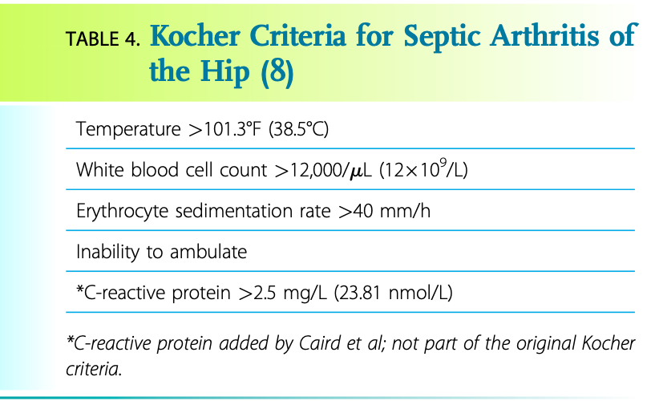
Herman, MJ, Martinek, M. The Limping Child. Pediatrics in Review.
  - If elements are present, the probability of septic arthritis was determined to be:
    - 0/4 = 0%
    - 1/4 = 3%
    - 2/4 = 40%
    - 3/4 = 93%
    - 4/4 = >99%
- Osteomyelitis
  - Hx: fever and limping that slowly worsens over 1-3 days
  - Physical Exam: extremity induration, swelling or fullness, local tenderness and painful range of motion of hip, knee or ankle.
  - X-Ray deep soft tissue swelling, periosteal reaction at 7-10 days, WBC, ESR, CRP elevated, MRI best test
  - Rx: IV Antibiotics, possible surgical drainage or debridement
- Iliopsoas Abscess
  - Cause: primary abscess from bacteremia
  - Hx: back, flank, abdominal pain, hip pain, +/- fever
  - CT or MRI
- Juvenile Idiopathic Arthritis
  - Autoimmune, children <16
  - Hx: joint pain, swelling, stiffness worse in am >6 weeks without detectable cause, systemic symptoms (lethargy, loss of appetite), can be polyarticular
  - X-Ray typically normal, MRI showing synovitis, elevated ESR, CRP
  - Rx: rheumatology referral
- Lyme
  - hematogenous spread into joint, any age
  - Hx: joint pain, swelling, possible chronic Lyme symptoms (heart block, etc.)
  - X-Ray typically normal, MRI showing synovitis, elevated ESR, CRP
  - Rx: 28-day course of doxycycline or equivalent Lyme treatment

Developmental/Congenital:
- Developmental Dysplasia: abnormalities of the acetabulum and femoral head, hip instability and dislocation
  - Commonly diagnosed in neonates
  - Hx: painless limp, activity related hip pain
  - Physical exam:
    - leg-length discrepancy (1-3cm)
    - Bilateral: wide-based, waddling gait, Trendelenburg limp
    - Unilateral: hop over the normal leg, walks on his or her toes on the shorter side
    - Older child: Trendelenburg, hip girdle muscle weakness, painful, limited ROM
- Slipped Capital Femoral Epiphysis: displacement of proximal femoral epiphysis from the metaphysis of the femur
  - Physis is structurally weakened, slipping
  - Causes: metabolic, large mechanical stress, idiopathic
  - RF: 10-14 yo, obese, M>F
  - Hx: antalgic or Trendelenburg limp with out-toeing or external rotation of the affect leg, if unstable inability to bear weight or move
  - Physical Exam: limited internal rotation of affected hip
  - X-Ray: AP pelvis, frog lateral view of both hips, Klein’s line lateral to femoral head diagnostic
  - Prognosis:
    - 1/3rd bilateral disease
    - Stable (able to bear weight) excellent prognosis
    - Unstable (unable to bear weight): risk of avascular necrosis, complication in 50%
  - Rx: non-weight-bearing, surgical intervention
- 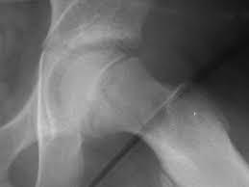
- Legg-Calve-Perthes Disease: idiopathic avascular necrosis of the femoral head
  - 2-12 yo (↑ 6-8 yo), M>F
  - Hx: painful limp
  - X-Ray diagnostic
  - Rx: NSAIDS, limited activity, PT
  - Prognosis
    - Younger children mild disease normal hip function after
    - Older children or severe disease risk from premature osteoarthritis
- 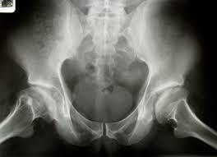
- Hemophilia, sickle cell, Gaucher’s disease

Neoplasms:
Malignancy:
- primary bone tumors, Leukemia, lymphoma, soft tissue sarcoma, bone metastases
  - Malignancies:
    - Osteosarcoma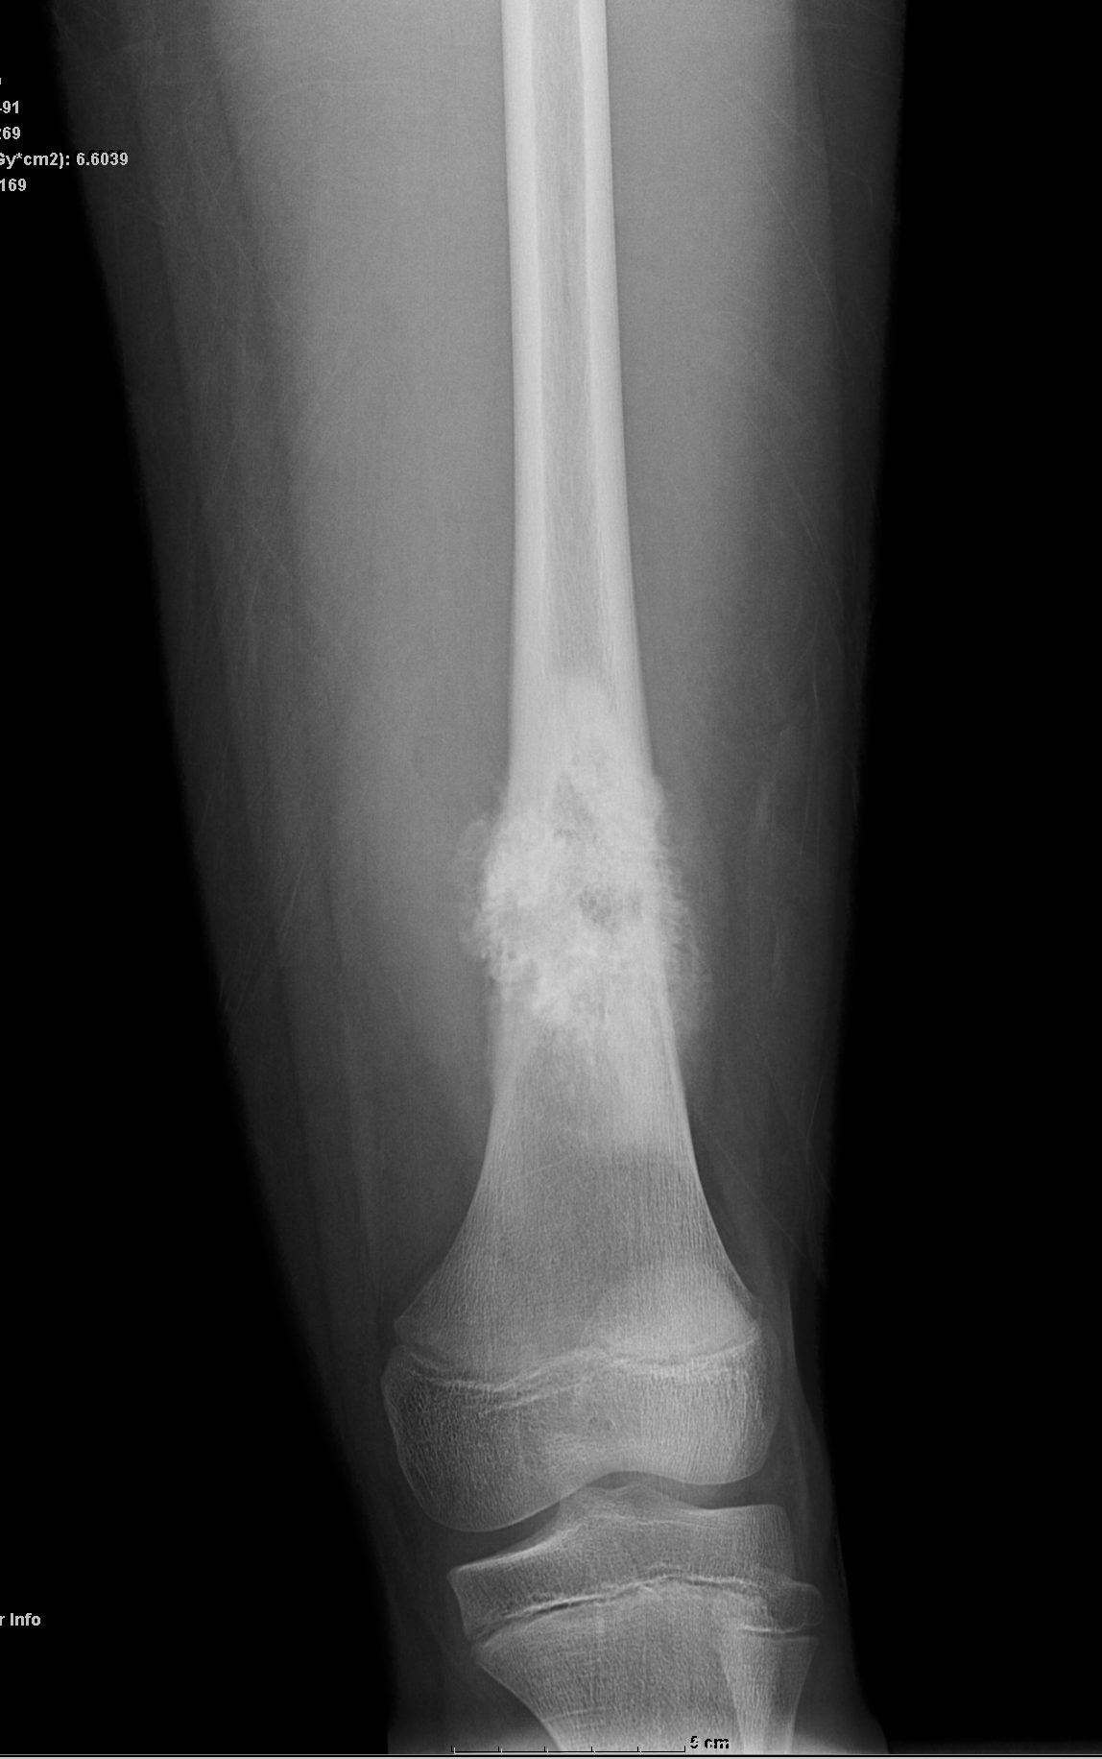
    - Ewing sarcoma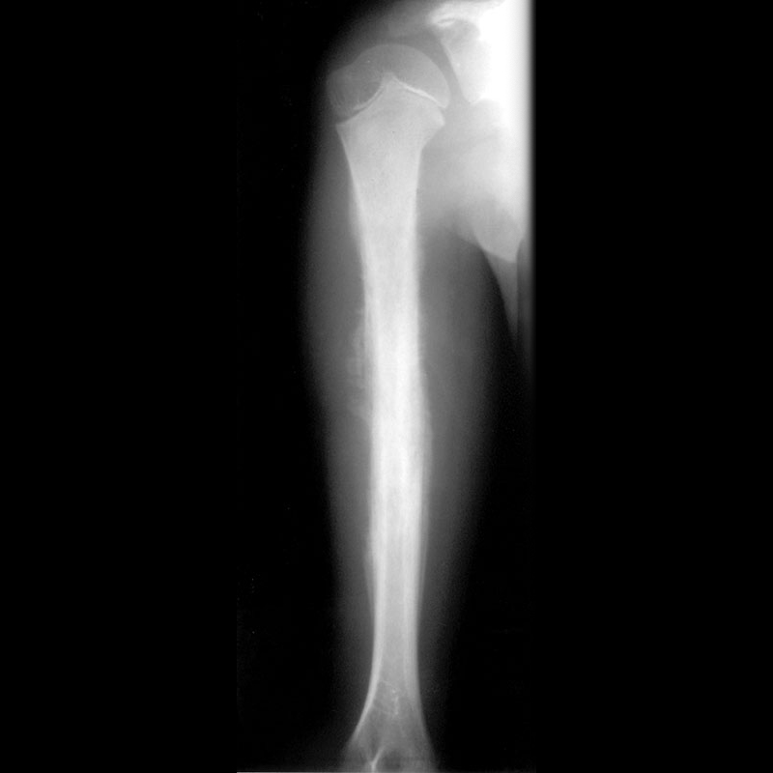

- Night pain or pain at rest, migratory bone or joint pain, generalized weakness, ecchymoses
- Low WBC, low to normal platelets
- Most common osteosarcoma, peak age 10
Benign Tumors:
- Osteochondroma: benign exostoses on metaphysis of distal femur and proximal tibia
  - Hard mass, age 3-4
  - X-Ray
  - Rx: excision, genetics consult if multiple lesions
- Osteoid Osteoma: benign lesion of cortical bone, discrete vascular nidus surrounded by reactive sclerotic bone
  - M>F, age 5-20
  - Pain, limping worse with activity and at night
  - X-Ray, CT, orthopedic surgery for excision

Orthopedic emergency/urgency:
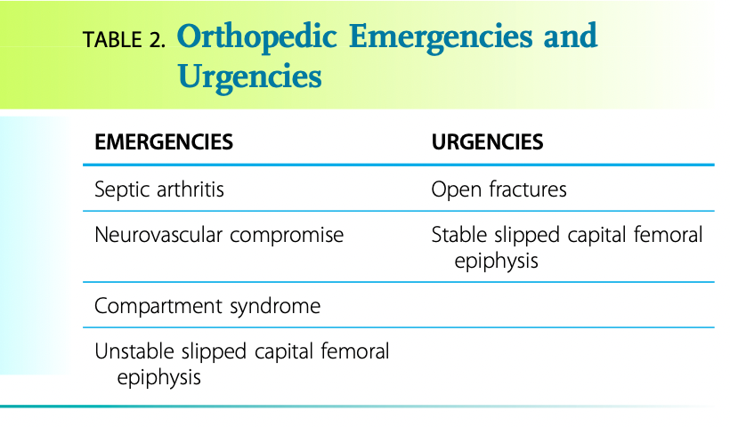
Herman, MJ, Martinek, M. The Limping Child. Pediatrics in Review.

References
Naranje S, Kelly DM, Sawyer JR. A Systematic Approach to the Evaluation of a Limping Child. Am Fam Physician. 2015 Nov 15;92(10):908-16. PMID: 26554284.

Herman MJ, Martinek M. The limping child. Pediatr Rev. 2015 May;36(5):184-95; quiz 196-7. doi: 10.1542/pir.36-5-184. PMID: 25934907.

Abdelgawad, Amr, and Osama Naga. “Approach to a Limping Child.” Pediatric Orthopedics, Springer New York, 2013, pp. 485–92, http://dx.doi.org/10.1007/978-1-4614-7126-4_17.

Barkin, Roger M., et al. “The Limping Child.” The Journal of Emergency Medicine, no. 3, Elsevier BV, Apr. 2000, pp. 331–39. Crossref, doi:10.1016/s0736-4679(99)00224-3.

“Please, Just STOP LIMPING! | Pediatric Emergency Playbook.” Pediatric Emergency Playbook, 1 July 2016, http://pemplaybook.org/podcast/please-just-stop-limping/.

