Pediatric Fracture Module Cases
Mark DeBuse, MD

Case 1:

Chief Complaint
7-year-old girl with left elbow pain

What does the patient look like?
The patient is an adolescent female sitting on the ED bed with mother at bedside. The child is quietly crying when you enter the room. She is interactive with mother and appears to be acting appropriately for her age. She is in no acute distress.

History
Source: Patient and mother
HPI: The patient is a 7-year-old right-hand-dominate otherwise healthy girl with no significant past medical or surgical history who presents within an hour after falling off a balance beam at gymnastics practice onto her left arm.
- No head or neck trauma
- No loss of consciousness
- Ambulatory without assistance after fall.
PMHx: None
Meds: None
Allergies: None
Family Hx: Non-contributory
Social Hx: She is in the second grade living at home with mom dad and her younger brother who is in kindergarten.

Action
Obtain physical exam.

Exam
VS: HR 100 bpm, RR 20 (crying) per minute, BP 96/40, Sat 99% (RA)
General: pleasant, cooperative child sitting on bed, mother in chair on right side holding patient’s right hand. Patient with tears, not wanting to move left upper extremity due to pain.
HEENT: AT/NC, MMM, PERRLA
Neck: Supple, no, TTP, FAROM without pain
Chest: No tenderness, normal symmetric respirations, CTAB
CV: HR 100, regular rhythm 2+ radial and DP pulses bilaterally
Abdomen: Soft, Non-tender, non-distended.
Focused LUE MSK Exam:
- L shoulder/upper arm – no swelling or ecchymosis non-tender.
- L elbow with intact skin, soft tissue swelling and ecchymosis in the AC fossa
- P/AROM limited due to pain
- SILT in C5-T1 dermatomes
- Motor intact in AIN, PIN, radial, median, and ulnar nerves distally.
- Fingers are warm and well-perfuses, CR < 2 sec, 2+ radial pulse
Neuro: GCS 15, acting appropriately
Skin: warm, intact, ecchymosis to left AC fossa as above.

Instructor prompt
What is on your differential diagnosis?
- Supracondylar humerus fracture
- Medial epicondylar fracture
- Lateral condyle fracture
- Olecranon fracture
- Elbow dislocation

Action
- Acetaminophen, ibuprofen
- Ice to the elbow
- topical lidocaine cream to Right AC fossa
- Place IV in RUE
- X-rays Left elbow (forearm)
- Make patient NPO (except medications)

X-ray Results
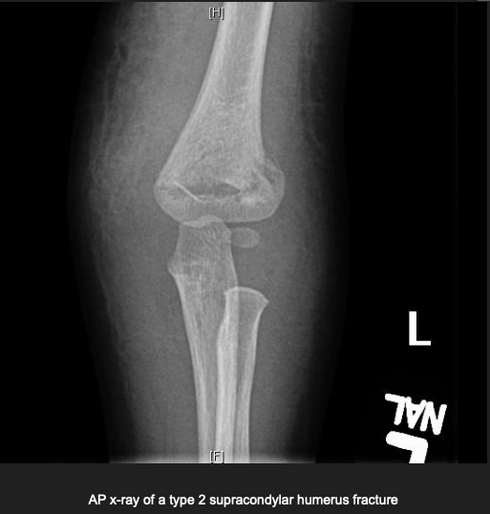

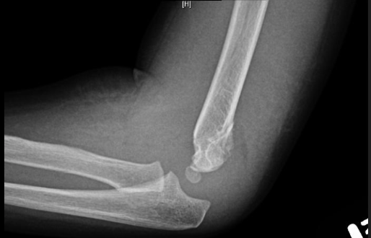

Action
- Consult to (pediatric) orthopaedic surgery

Diagnosis: Type II Supracondylar Humerus Fracture

Critical actions
- Perform trauma survey to assess for other injuries
- Determine neurovascular status of injured extremity
- 10 Sec Neuro Hand Exam: https://www.youtube.com/watch?v=jYvBlK3KZWc
- Address pain (po, possibly IV)
- Make patient NPO pending orthopaedic surgery evaluation
- Once X-ray results are back, make decision to consult orthopaedic surgery
- Admission to hospital for closed reduction and percutaneous pin fixation with orthopaedic surgery
- If need to transfer to other facility, place in long arm splint without reduction, reassess neurovascular status post-splint.

Instructor Guide
- Supracondylar humerus (SCH) fractures are the most common fracture in children, most often occurring between ages 5 and 7-years-old. Typical mechanism of injury is from a fall on to an out-stretched arm.
- Diagnosis can be made with plan x-rays (AP, lateral, and oblique) of the elbow.
- Classification determines treatment with Type I (nondisplaced) typically treated in a long-arm cast (bivalved to allow for swelling), and Types II and III with closed reduction and percutaneous pinning (CRPP) by orthopedic surgeon
- The urgency of operative intervention depends on presence/absence of hand perfusion.

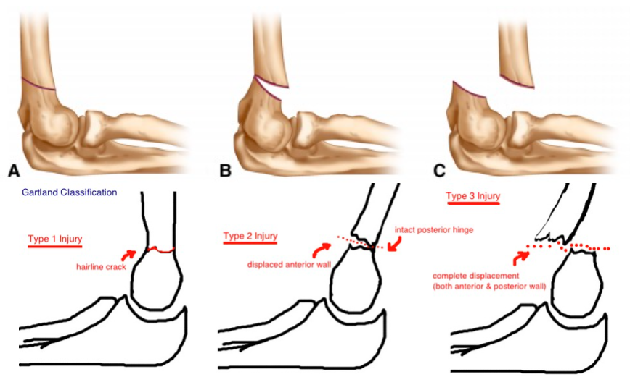

Case Teaching Points

- Perform an upper extremity neurovascular examination
- Interpret pediatric elbow radiographs
  - In this case, the anterior humeral line (drawn on the on the lateral x-ray) does not intersect the capitellum, indicating a SCH fracture.
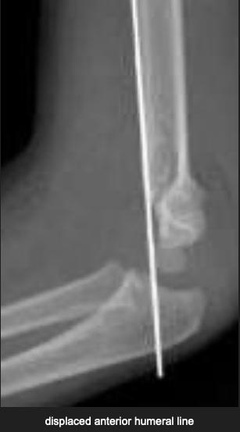
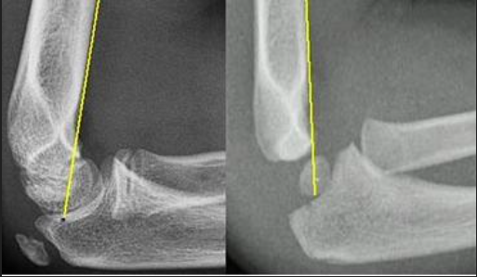

References:

- Woon, C., Souder, C, and Skaggs, D. Shirley E. Supracondylar Humerus Fracture
https://www.orthobullets.com/pediatrics/4007/supracondylar-fracture--pediatric
Updated: 8/31/2021

- Rang’s Children’s Fractures, 3rd Ed., Wenger, D. and Pring, M., 2005, pp. 95-108

Case 2:

Chief Complaint
8-year-old boy with right arm pain

What does the patient look like?
The patient is an adolescent male sitting on an ED bed with his father at his side. The child is sitting quietly when you enter the room being reassured by his father. He is interactive with the father and appears to be acting appropriately for his age. He is in no acute distress.

History
Source: Patient and father
HPI: The patient is an 8-year-old right-hand-dominate otherwise healthy boy with no significant past medical or surgical history who presents within an hour after falling off his bike outside his house onto his right arm.
- He was wearing a helmet
- No head or neck trauma
- No loss of consciousness
- Ambulatory without assistance after fall.
PMHx: None
Meds: None
Allergies: None
Family Hx: Non-contributory
Social Hx: He is the third grade, lives at home with mom dad and younger sister who is in first grade

Action
Obtain physical exam.

Exam
VS: HR 99 bpm, RR 18 per minute, BP 100/50, SpO2 99% (RA)
General: pleasant, cooperative child sitting on bed, father in chair beside bed. Patient with tears, but no longer actively crying, does not want to move right upper extremity due to pain.
HEENT: NC/AT, MMM, PERRLA
Neck: Supple, no, TTP, FAROM without pain
Chest: No tenderness, normal symmetric respirations, CTAB
CV: HR 100, regular rhythm 2+ radial and DP pulses bilaterally
Abdomen: Soft, Non-tender, non-distended.
Focused RUE MSK Exam:
- R shoulder/upper arm – no swelling or ecchymosis non-tender. Full A/PROM
- R elbow with intact skin, soft tissue swelling to elbow and forearm with associated, difficult to localize TTP, elbow ROM deferred due to pain; FAROM of R wrist and hand.
- SILT in C5-T1 dermatomes
- Motor intact in AIN, PIN, radial, median, and ulnar nerves distally.
- Fingers are warm and well-perfuses, CR < 2 sec, 2+ radial pulses bilaterally
Neuro: GCS 15, acting appropriately
Skin: warm, intact, no abrasions or lacerations

Instructor prompt
What is on your differential diagnosis?
- Elbow fracture (supracondylar, epicondylar, condylar, olecranon)
- Elbow dislocation
- Radial head fracture or dislocation
- Radius fracture
- Ulnar fracture
- Monteggia fracture/dislocation

Action
- Acetaminophen, ibuprofen
- Ice to RUE
- topical lidocaine cream to Right AC fossa
- Place IV in LUE
- X-rays Left elbow and forearm
- Make patient NPO (except medications)

X-ray Results
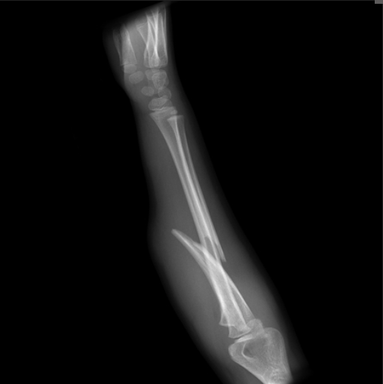

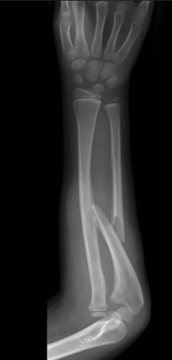

Action
- Consult to (pediatric) orthopaedic surgery

Diagnosis: Monteggia Fracture

Critical actions
- Perform trauma survey to assess for other injuries
- Determine neurovascular status of injured extremity
- 10 Sec Neuro Hand Exam: https://www.youtube.com/watch?v=jYvBlK3KZWc
- Address pain (po, possibly IV/IN)
- Assess for open fracture (antibiotics, Tdap)
- Make patient NPO pending orthopaedic surgery evaluation
- Once X-ray results are back, make decision to consult orthopaedic surgery
- Prepare for procedural sedation
- May be treated closed if ulnar reduction is out-to-length and stable. Radial head typical spontaneously reduces with ulnar reduction.
- Admission to hospital for open fractures, unstable ulnar length, or radial head reduction cannot be maintained.
- If need to transfer to other facility, place in long arm splint, reassess neurovascular status post-reduction and post-splint.

Instructor Guide
- Monteggia fractures/dislocation consist of two parts:
  - Radial head dislocation plus
  - Proximal ulna fracture (or plastic deformation without obvious fracture)
- Demographics: most commonly 4-10 years-old
- MOI: fall on outstretched upper extremity

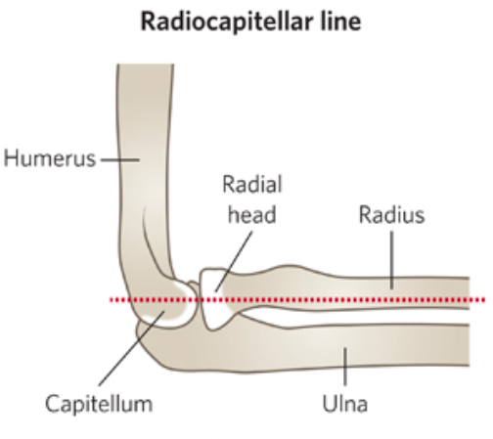
Case Teaching Points

- Perform an upper extremity neurovascular examination
- Interpret pediatric elbow/forearm radiographs
- In this case, Radiocapitellar Line: line drawn down mid-shift of radius should bisect capitellum. If not, the radial head is dislocated.
- Radial head may spontaneously reduce, so always palpate radial head when ulna fractures are seen.
- Radial head dislocations rarely occur in isolation, so always obtain elbow and forearm films when a radial head fracture or dislocation is suspected.
- Skin can be open or at risk, assess for puncture wound which will indicate open fracture requiring IV antibiotics and operative assessment by orthopaedic surgery for irrigation and fixation.

References:

- Allen, Deborah, Monteggia Fracture - Pediatric
https://www.orthobullets.com/pediatrics/4015/monteggia-fracture--pediatric
Updated: 6/12/2021 (Ortho Bullets reference all photos)

- Rang’s Children’s Fractures, 3rd Ed., Wenger, D. and Pring, M., 2005, pp. 131-134

